Use-Case Realization Report (Analysis)
Transfer All Cash

Issue 3.0
Revision History
Date | Issue | Description | Author
17 July 2000 | 1.0 | First Issue | Howard Russon
2 August 2001 | 2.0 | Revised for MTech Unit 3 in 2001 | Howard Russon
21 July 2004 | 3.0 | Revised for MTech Unit 3 in 2004 | Howard Russon

Table of Contents
1. Brief Description 4
2. Flow of Events 4
2.1 Standard Flow 4
2.2 Exceptions 4
3. Interaction Diagrams 5
3.1 Collaboration Diagram: Transfer All Cash 5
4. Participating Objects 5
5. Class Diagrams 7
5.1 Class Diagram: Transfer All Cash 7
6. Derived Requirements 7

Use-Case Realization Report
Transfer All Cash

Brief Description
This abstract use case enables all the coins in the vending machine to be issued to the Maintainer.

Flow of Events
The standard flow of events for this use case and any exceptions are described in the following subsections. The events are described in terms of Actors and Analysis Objects.

Standard Flow
This use case is used to enable the Maintainer to collect all the cash currently held by the machine. The flow of events is shown in section 3.1 and described as follows:
- When the Maintainer presses the Transfer Cash Button on the Maintenance Panel, the operation TransferCashRequest of the Transfer Cash Button will use the TransferAll operation of the Transfer Cash Controller.
- The Transfer Cash Controller will then use operation TransferAll of the Cash Store to instruct it to empty its contents and return the total amount of cash to be transferred. to achieve this, for each Coin denomination held in the Cash Store, it instructs the Coin object to set the number of Coins held to zero by using its operation SetQuantity.
- The Transfer Cash Controller will then use operation DisplayCoins of the Cash Collection Tray Display (of the Maintenance Panel) to instruct it to display the amount of cash transferred on the Cash Collection Tray Display.
- The Transfer Cash Controller will then use operation DisplayCoinQuantity of Store Controller to instruct it to update the coin denomination quantity display (show zero values) on the Cash Store Display of the Machinery Simulator Panel. The Store Controller will achieve this as follows for each denomination:
- Use operation GetQuantity of Cash Store to determine the total number of Coins of the denomination held. This in turn uses operation GetQuantity of the corresponding Coin.
- Use operation Update of Cash Store Display to display the value.

Exceptions
The following exceptions have been identified:
- Fault is Detected. If, in the process of issuing the cash to the Maintainer, the sensors detect a fault in the internal mechanism of the vending machine, then a fault message should be returned. Note that this fault is not required to be represented by the simulation.

Interaction Diagrams

Collaboration Diagram: Transfer All Cash
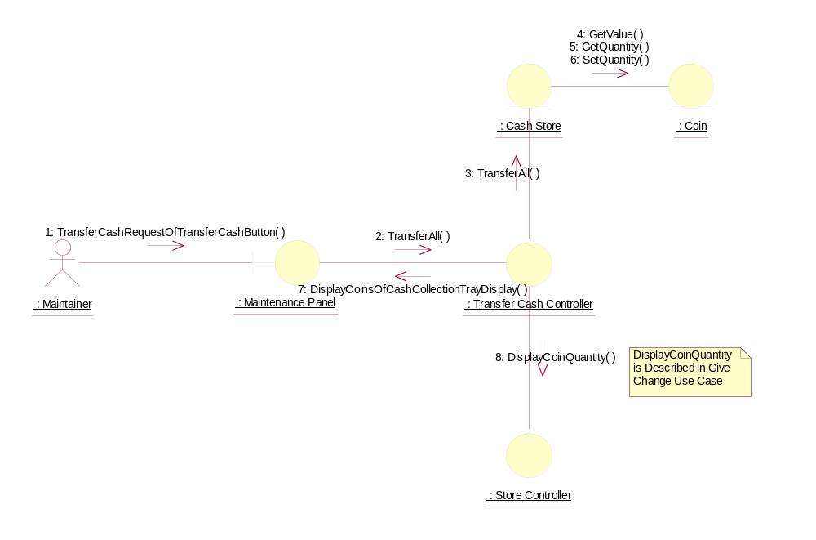

Participating Objects
: Cash Store
This object represents the store of cash in the vending machine.
: Coin
This object stores the weight and value of each type of Coin, and hence enables the machine to recognise each Coin entered.
: Maintainer
This actor represents the vending machine maintainer who will have a simple display panel to enable stock levels of drinks-cans and change to be monitored, and to enable cash within the machine to be collected.
: Maintenance Panel
This panel simulates the vending machines maintainer control panel. It will enable the user (the Maintainer) to:
1 log-on using a password;
2 display number of Coins of each denomination in the Cash Store;
3 display total value of cash in the system;
4 display number cans of each Drinks Brand held in the Drinks Store;
5 change the price of any Drinks Brand;
6 collect all cash held in system;
7 formally exit from the panel.
: Store Controller
This object controls the Change State use case. It mangages changes in Cash Store attributes and the Drinks Store attributes. It also handles the door status. It is also used by the Dispense Drink use case to update the Drinks Store attributes.
: Transfer Cash Controller
This control object handles the transfer of all cash collected in the vending machine to the maintainer.

Class Diagrams

Class Diagram: Transfer All Cash
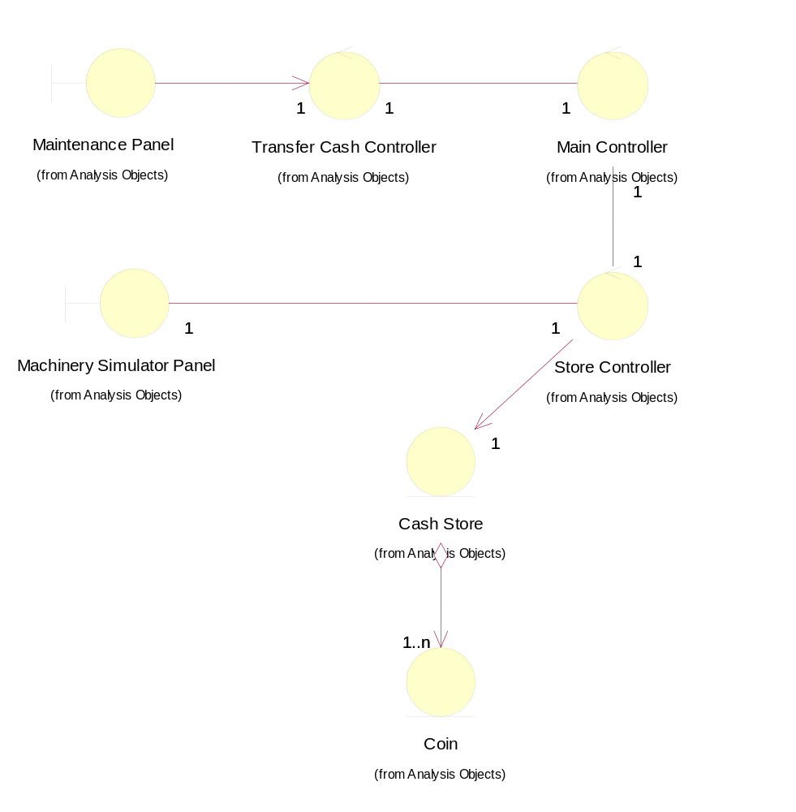

Derived Requirements
There are no special requirements associated with the host implementation. However, in the target implementation, a physical cash tray is required to be built into the Maintenance Panel to catch the cash, so that it can be collected by the Maintainer.

